**Create a Dropdown Menu with Adobe XD**

**Create a rectangle for the menu**

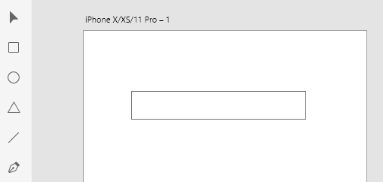

**Add text, and then two short lines for the arrow**

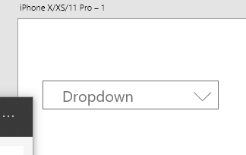

**Group the two short lines, and change the group name to “arrow”** 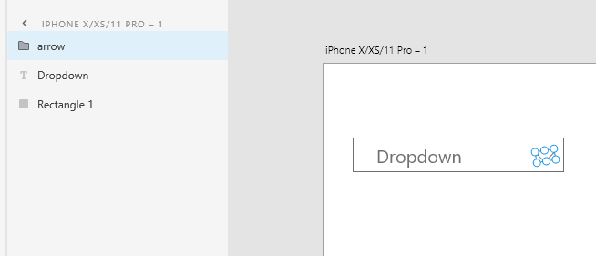

**Select all items and make a component, and give the component a name “DrowdownMenu”**

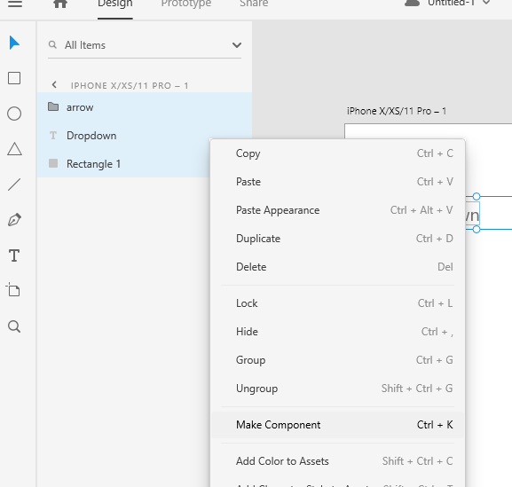

**Add a state to the component, call it Open State**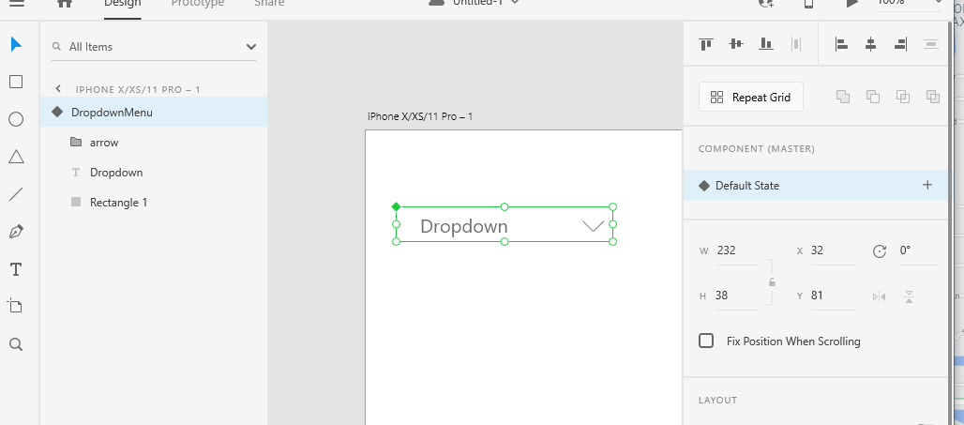

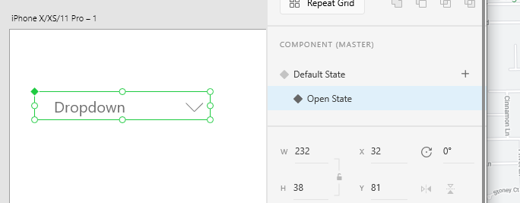

**then add a rectangle and the text for the item, group them, give the group a name**

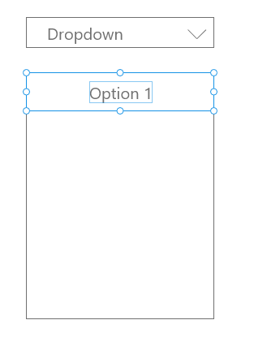

**Make copies of the option**

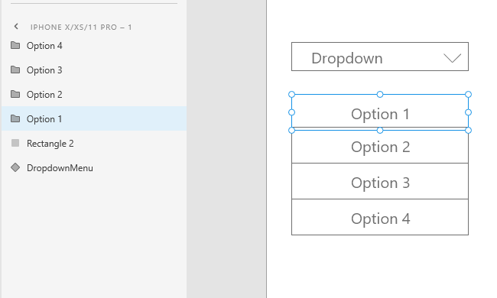

**Group all options and the rectangle which holds them into one group, I call it Options**

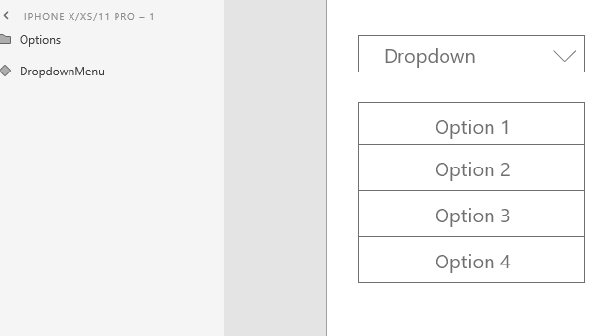

**Select the Open State for the Dropdown Menu component**

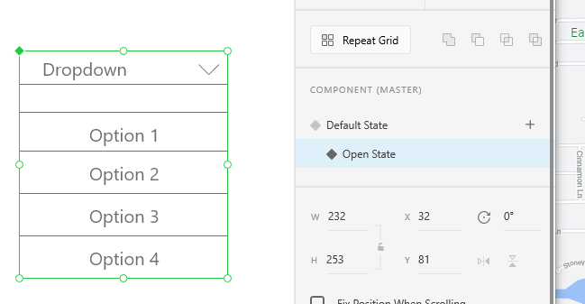

**Select Options, then right click to copy**

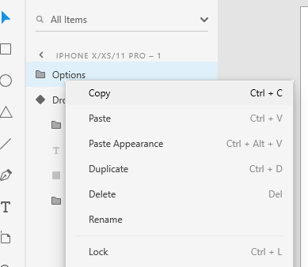

**Paste below the last item in the DropDownMenu component**

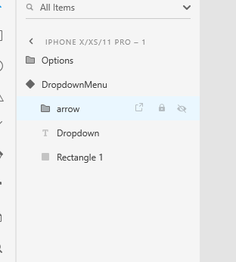

**Since the Options group has already been paste to the DropdownMenu, you can delete it or hide it. If you chose to hide it, you need to choose the default status of DropdownMenu and hide it again.**

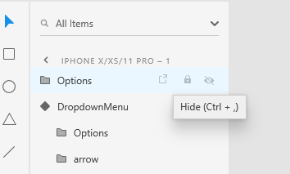

**Default status should be like this**

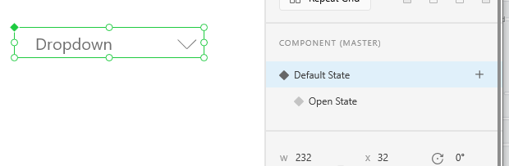

**Open status should be like this. The arrow’s direction should be changed**

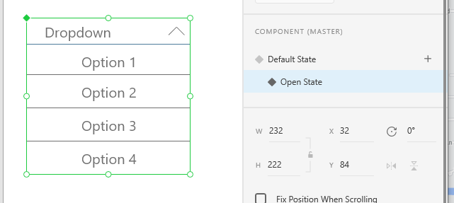

**In Prototype, select the Default State, then add an Interaction**

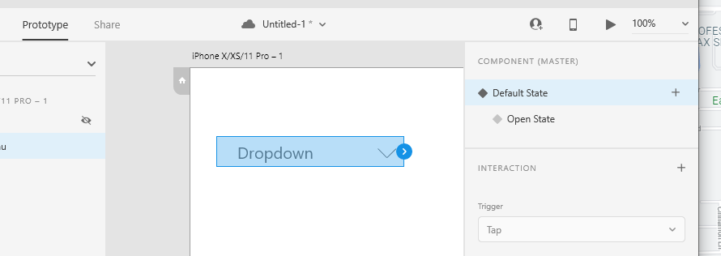

**Choose Open State**

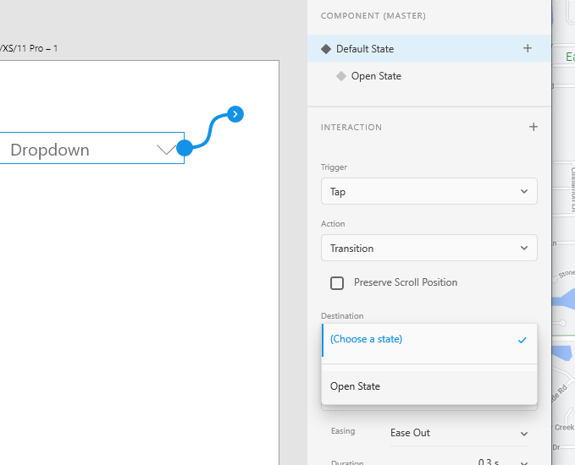

**Select the Open State-> Select the rectangle in the circle below->add an interaction-> chose Default State as the Destination**

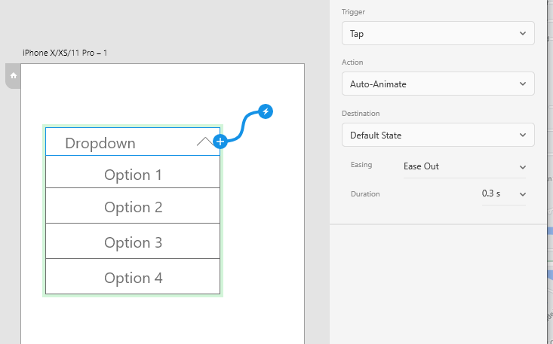

**Preview**

